Restaurant Website Project Report

Our Roles in the Website

* Pratya coded the ordering page of the hotel/restaurant and she also did the page that involved the hotel suites and the different types of rooms available for each person to stay in. She also added the pictures and did the photo gallery of the interior and the exterior of the cottages like the rooms. She also did the footer of the website. She also did the contact page so people would know how to contact the restaurant.
* Doyel coded the navbar of the website and she also did the menu and the food items in the menu as well as the buttons. She also did the photo gallery for the suite pictures like the interior and the exterior pictures. She also did the descriptions for the hotel and the cottages and the suites.

# What you learned while building the project

* We learned basically how to make the structure of the website like the nav bar and the footer. We also learned how to link many pages in our website to the nav bar. The color scheme of the website was really important to us because it helps grab the viewer’s attention. We learned how to make an image gallery and the user would press the right or left arrows to view whatever image we want.

Did u take any courses like coursera, udemy...etc ,,while working for ur project .

* We did not use any courses but we used youtube videos and websites like w3schools to help us with our website

Mention the libraries what u have installed for the project.

* We used bootstrap libraries

## .Also explain the work flow of the project

1. First we brainstormed ideas about what our hotel and restaurant should look like and we decided on a beachside hotel and restaurant in Thailand 2. Next we coded the basic structure of the website like making an html,css and javascript pages

1. We coded the pages of the website like the dining, hotel, booking, accommodations and contact and we connected those links to the navbar
2. We added the pictures in the image carousel
3. We did the ordering page

Screen shots

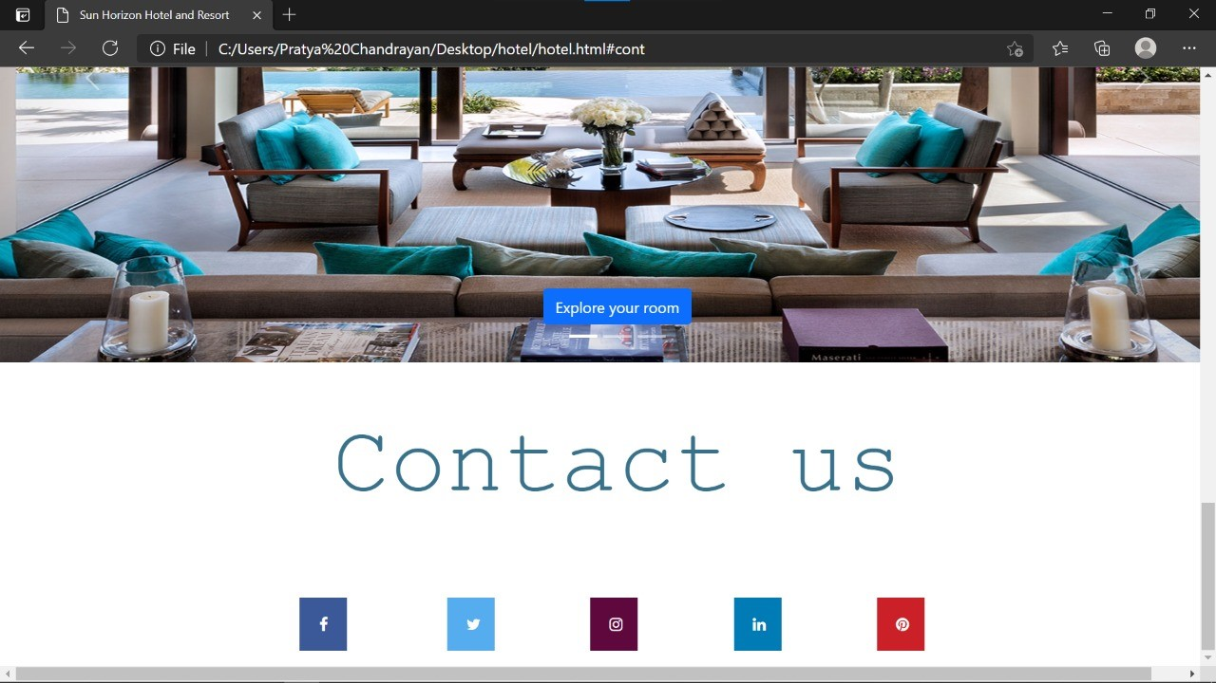

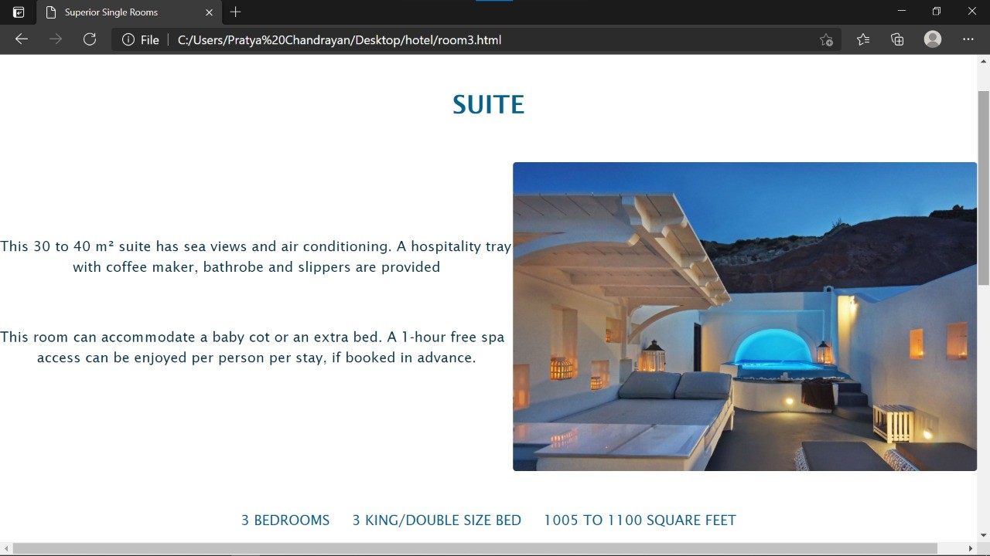

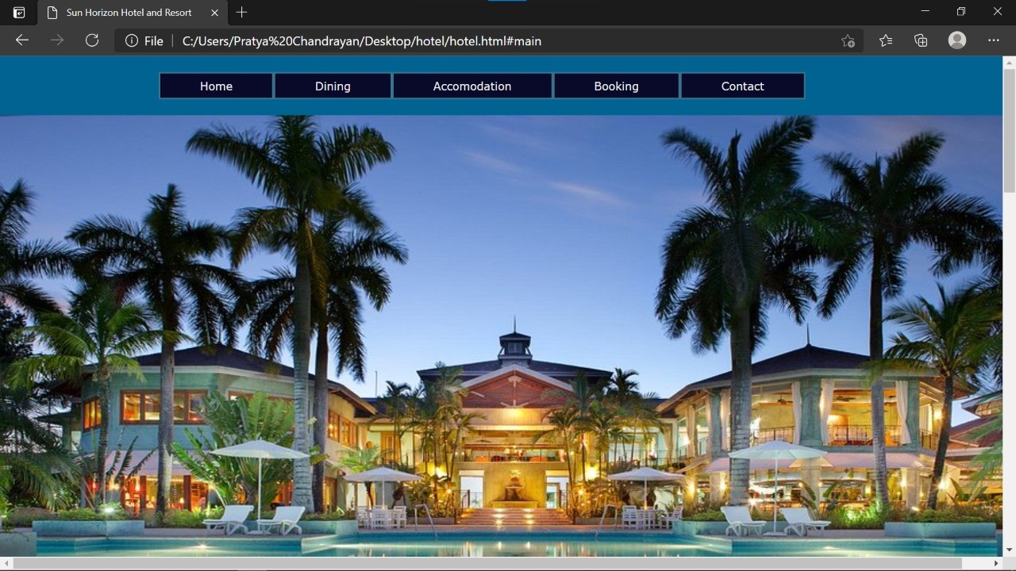



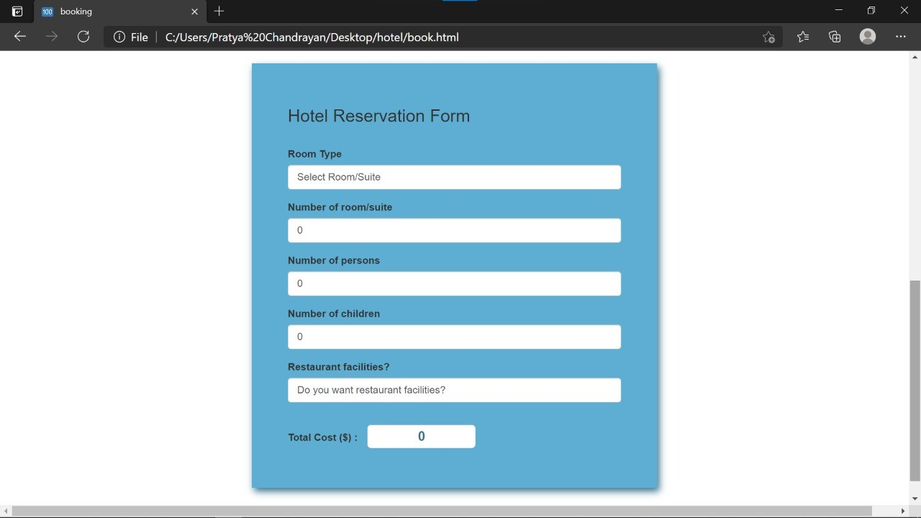

Github repo:

<https://github.com/pratya08/Pratya.hotel.github.io.git>